SEPTEMBER 2025

Sun Mon Tues Wed Thurs Fri Sat

|  |  |  |  |  |  |  |
| --- | --- | --- | --- | --- | --- | --- |
|  | 1  7.30pm-9.30  Spirit & Soul  Awareness Circle | 2  DIVINE MYSTICAL  SCHOOL  10-4 | 3  10.00am- 12  Cosmic Star Meditations | 4 | 5 | 6 |
| 7 | 8  7.30pm-9.30  Spirit & Soul  Awareness Circle  Full Moon ~ Pisces | 9 | 10  10.00am- 12  Cosmic Star Meditations | 11 | 12 | 13 |
| 14 | 15  7.30pm-9.30  Spirit & Soul  Awareness Circle | 16 | 17  10.00am- 12  Cosmic Star Meditations | 18 | 19 | 20  OCEAN STAR GATES  Workshop 10.00am -4 |
| 21 | 22  7.30pm-9.30  Spirit & Soul  Awareness Circle | 23 | 24  10.00am- 12  Cosmic Star Meditations | 25  CRYSTAL SOUND HEALING  7.30-9.00 | 26 | 27 |
| 28 | 29  7.30pm-9.30  Spirit & Soul  Awareness Circle | 30 |  |  |  |  |

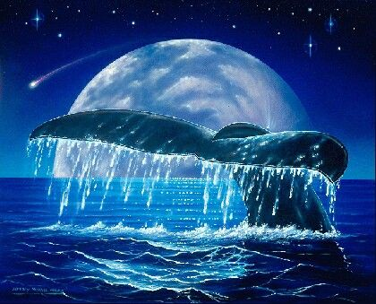

Whales bring Love, through the

Water Body system, Our Mother Ocean

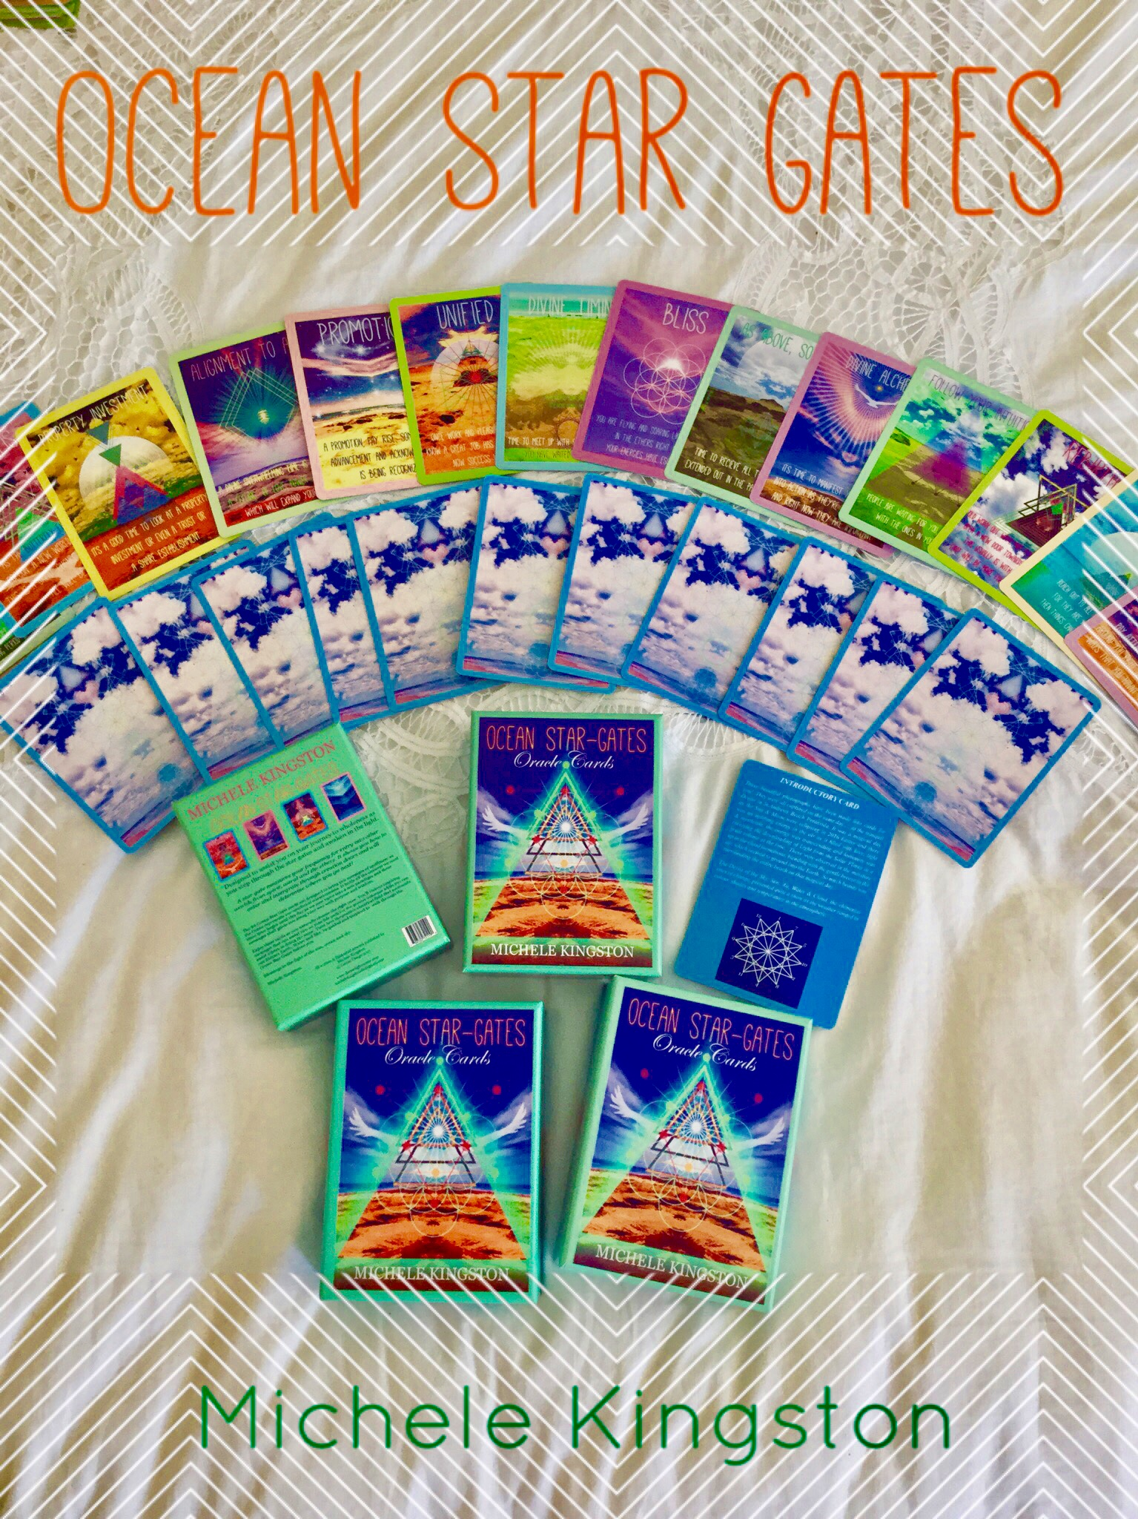

OCEAN STAR GATES Workshop

